Victor Anisi (RA) and Dr. Serveh Kamrava (PI)

Phase-2 ECMC PROJECT report: ann-svm ensemble model


An improved ANN–SVM model for pipeline failure risk
Brief Introduction
Our earlier paper showed that our artificial neural network (ANN) and support vector machine (SVM) were the strongest single learners for the multiclass pipeline failure risk. Both models achieved an overall accuracy of 0.90. Still, they struggled most with the Low and high risk classes, incorrectly classifying several Low cases as High due to class imbalances within both the training and out-of-sample test datasets. This report retains the same data, labels, and 70/30 stratified split, while updating the training and combination of the ANN and SVM. Our new code introduces three changes: (i) class aware training for the ANN using focal loss, (ii) class balancing with SMOTE–Tomek after cleaning, version safe preprocessing pipeline, and (iii) two ways to combine learners—an adaptive vote that weights each learner by its per case confidence and a stacked combiner trained on the base probabilities. Small, physically sensible features (such as $age ×pressure$, ${age}/{pressure}$, total spill volume, spill-type count, ${age}^{2}$, and $\log{age}$) were added to expose structure already present in the table. No new external data was used.

Improved Methodology
Numerical columns were median imputed and scaled with a robust scaler; encoded categorical data were mode imputed and one-hot encoded. After preprocessing, we used SMOTE–Tomek and balanced the classes and removed Tomek links near the decision boundaries. The ANN used three hidden blocks (256–128–64) with batch normalization, dropout, and L2 weight decay; ReLU activations; softmax output; and focal loss with $α=0.25, γ=2$; early stopping and learning rate reduction limited overfitting. The SVM used a balanced weight class and a grid search over $C, γ, and kernel$. The adaptive vote formed a probability weighted average using each learner's confidence for the case. The stacked (hierarchical) ensemble trained a small gradient boosting model on the concatenated base probabilities plus their confidences. All models and transformers were saved for out-of-sample tests with the PHMSA data, mirroring the methodology in our previous manuscript.

Results and Discussion
The original ensemble presented in Fig. 1 and Fig. 4 already classified High and Medium well but made the costliest errors on the Low class; only 16 of 31 Low cases were correctly labeled Low, and 13 Low cases were called High. This weakness also showed up in ranking, AUC for Low was 0.917, far below Medium (0.998) and High (0.972). These numbers match the concern raised in the earlier paper. After adding focal loss and the adaptive confidence vote, the Low class changed the most, while the other classes remained constant. From Fig. 2 and Fig. 5, we observe that the correct Low calls increased from 16 to 28, and Low to High errors dropped from 13 to 2, with overall accuracy rising to 0.964. The ROC curves moved in the same direction; the AUC for the Low risk class increased from 0.917 to 0.991, the High risk class to 0.997, and the medium risk class to 1.0. The class-wise bars confirm that these increases were not a result of threshold choice. Furthermore, Fig. 3 depicts that our stacked combiner ANN-SVM ensemble pushed the discrete labels even further and yielded the best confusion matrices of all experiments. Accuracy increased to 0.975 with no medium errors, 95 of 97 High risk cases were predicted correctly, and 28 of 31 Low risk cases were predicted correctly, with only three Low risk cases called High. Moreover, precision for Low increased to 0.913, recall for Low remained 0.903, and F1 for Low increased to 0.909. The Medium risk class precision, recall, and F1 were 1, and the High risk class recall increased to 0.979, with F1 score remaining stable at 0.974 (as shown in table 1). Fig. 6 validates our earlier observation as the AUC stayed at 1.000 for Medium and 0.992 for High and at 0.973 for Low. Thus, compared with the adaptive vote ANN-SVM ensemble, the stacking ANN-SVM ensemble gives the most accurate final labels and a tighter balance between false alarms and misses in the Low class, while giving up a minimal margin in Low AUC. This is scientifically valid because the stacked combiner optimizes how scores map to labels at the working cutoff. At the same time, the adaptive vote maximizes rank ordering across thresholds, especially for the rare classes present in each dataset. Again, Table 1 shows that recall for Low reached 0.903, and High and Medium recalls stayed high (0.969 and 0.986, respectively). Precision for Low remained the hardest sub metric (0.875), which reflects a few extra Low predictions among near border cases. The F1 scores summarize this balance: 0.889 for Low, 0.986 for Medium, and 0.974 for High. Notably, the adaptive vote ANN-SVM ensemble raised the Low class ranking and cut the costly low-to-high risk class misclassifications, while preserving the strengths of the original model.

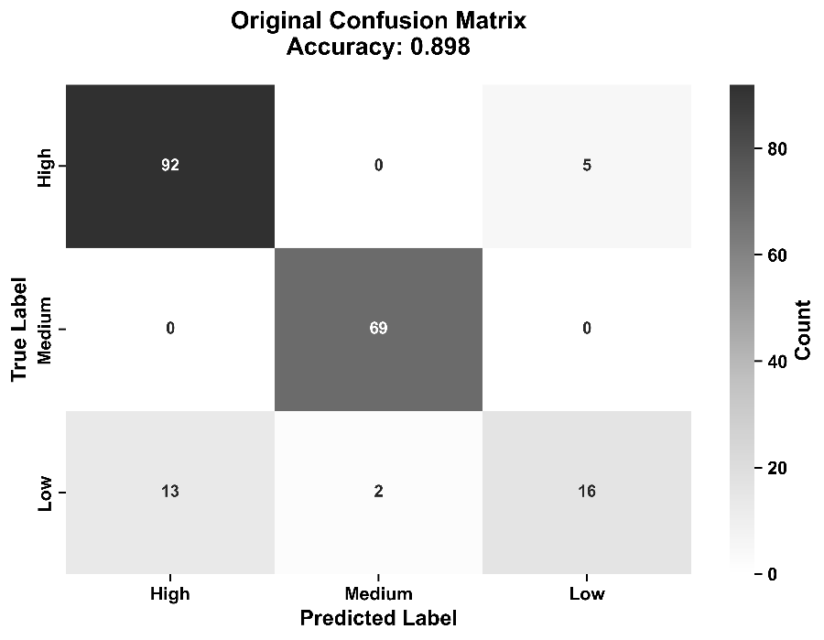 | 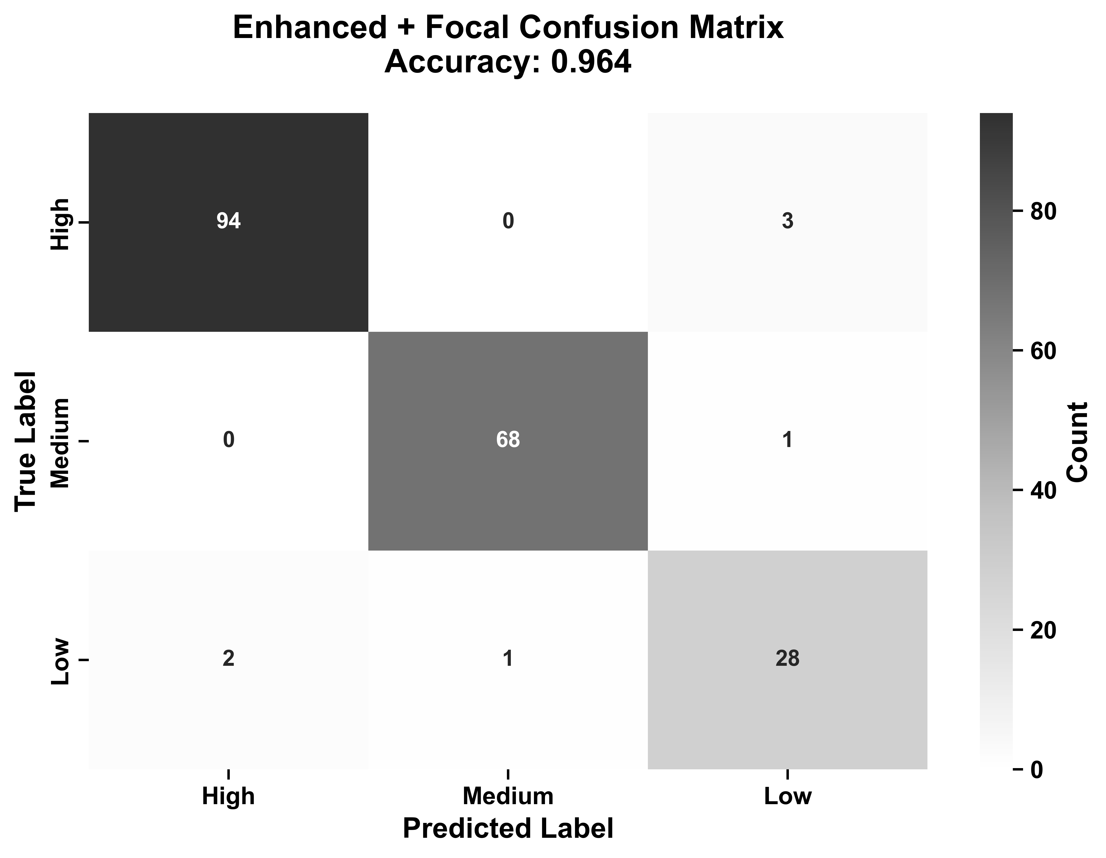
Fig. 1. Confusion matrix for basic ANN-SVM model | Fig. 2. Confusion matrix for adaptive vote ANN-SVM model

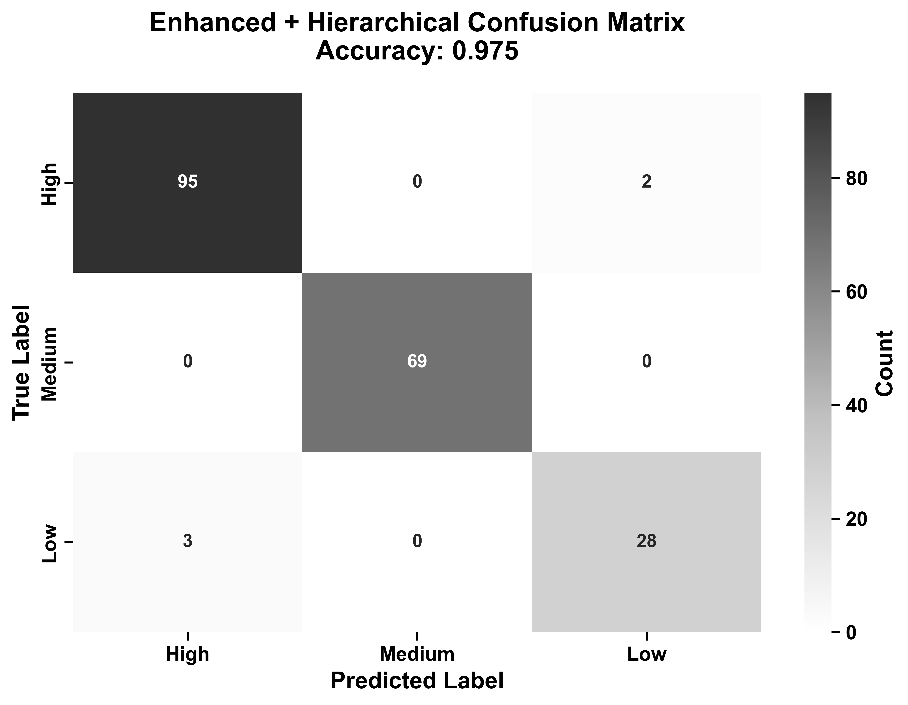
Fig. 3. Confusion matrix for stacking (hierarchical) ANN-SVM model

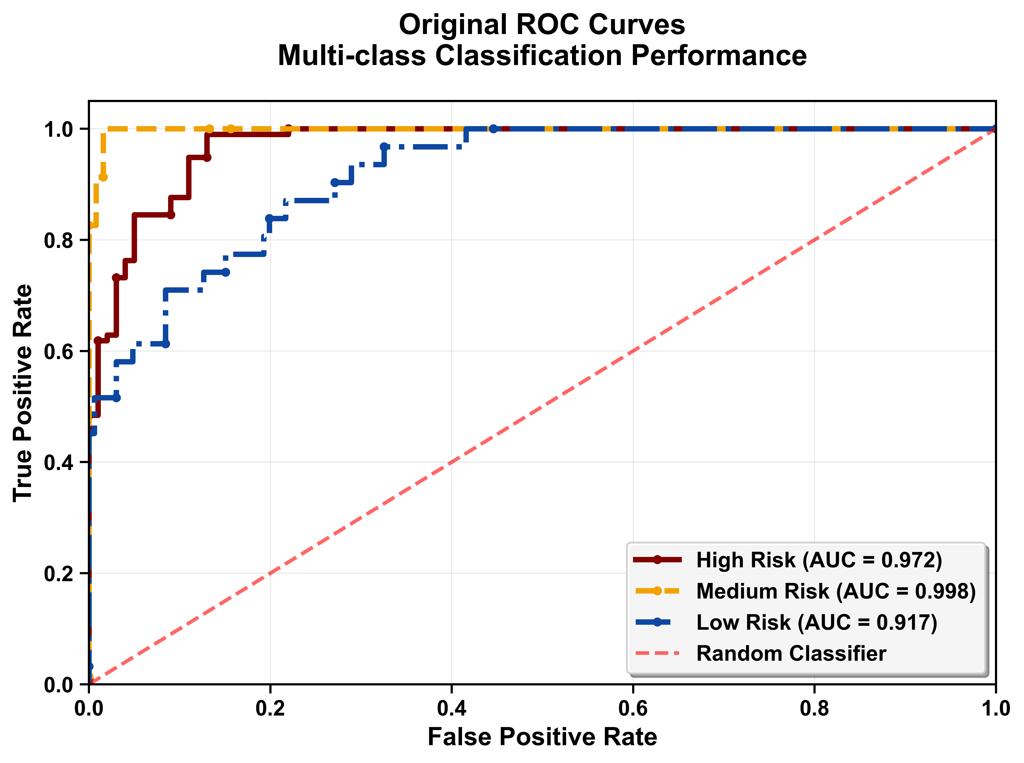 | 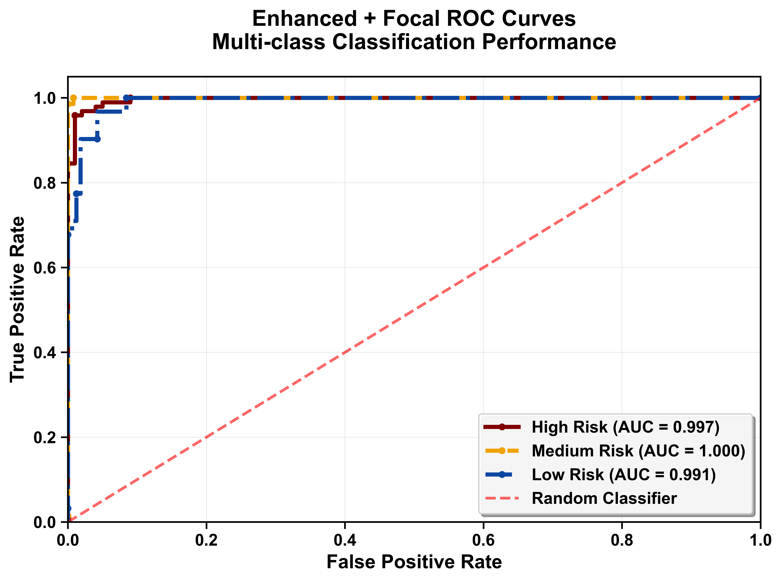
Fig. 4. ROC curve for basic ANN-SVM model | Fig. 5. ROC curve for adaptive vote ANN-SVM model

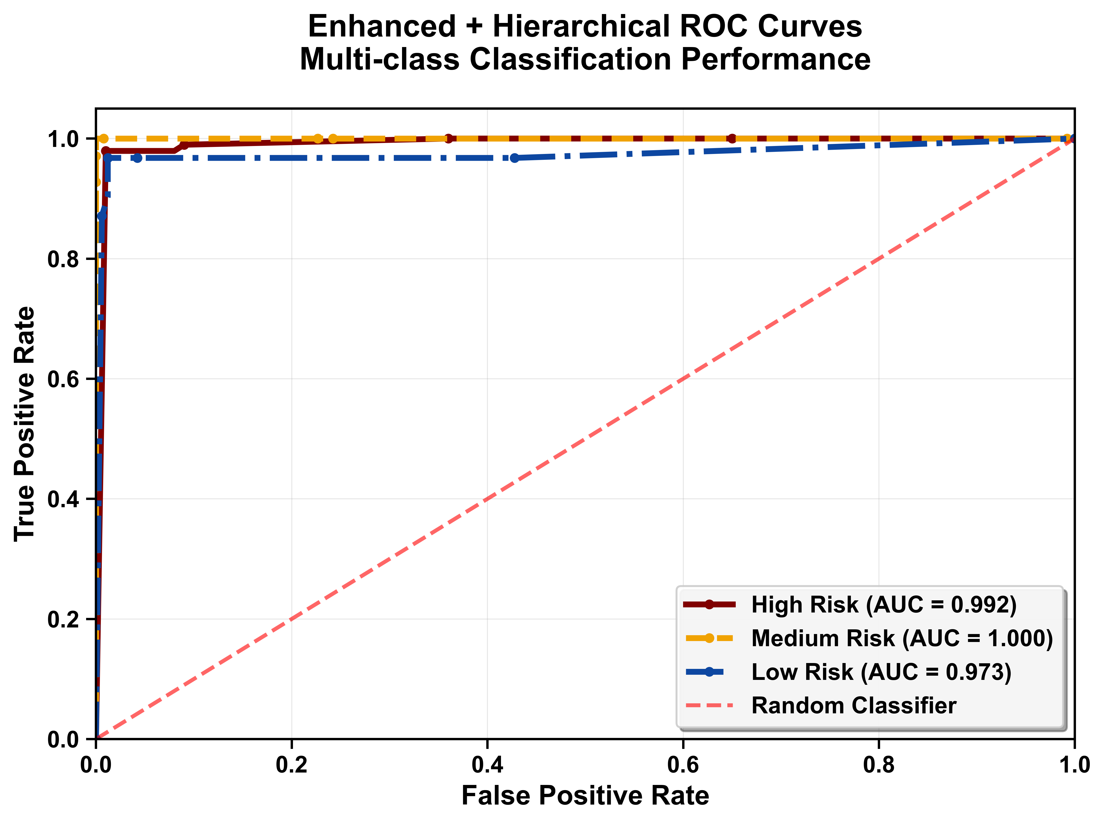
Fig. 6. ROC curve for stacking ANN-SVM model

Table 1- Prediction performance of ANN-SVM models on unseen dataset
Model | Class | Precision | Recall | F1-score | AUC | Accuracy
Adaptive ANN-SVM | High | 0.979 | 0.969 | 0.974 | 0.997 | 0.964
Adaptive ANN-SVM | Low | 0.875 | 0.903 | 0.889 | 0.991 | 0.964
Adaptive ANN-SVM | Medium | 0.986 | 0.986 | 0.986 | 1.000 | 0.964
Stacking ANN-SVM | High | 0.969 | 0.979 | 0.974 | 0.992 | 0.975
Stacking ANN-SVM | Low | 0.933 | 0.903 | 0.918 | 0.973 | 0.975
Stacking ANN-SVM | Medium | 1.000 | 1.000 | 1.000 | 1.000 | 0.975

These significant improvements are a result of our training methods. Fundamentally, focal loss and SMOTE–Tomek address the class mix directly and concentrate learning on complex, low, and high risk cases near boundaries. The small added features are physically reasonable and easy to compute and likely help both the SVM and the ANN learners separate age-pressure regimes and spill severity patterns. The two combinations rules, then use, rather than smooth out, the natural disagreement between ANN and SVM around the borders. The outcome of the final ANN-SVM ensemble is a remarkable drop in low-to-high risk classification mistakes and an increase in high risk class recall and F1 in out-of-sample tests with the PHMSA dataset, in contrast to the results we observed with the ANN model in our previous work, without compromising the already strong low and medium risk classification performance. The improvement is also practical in size, as evidenced by increased accuracy from 0.898 to 0.964 and 0.975, respectively. Additionally, the low AUC rose from 0.917 to 0.991/0.973, and the count of correct Low labels increased from 16 to 28, while high-to-low risk classification errors decreased from 13 to 2 and 3, respectively.
Consequently, the earlier work we presented in our manuscript concluded that ANN and SVM were the best single models, and that random forest overfitted on the proprietary data used for training. That generalization was uneven across classes, with high and low failure risk classes being the most impacted. The present results keep the same problem framework and data and improve exactly where it matters most. For operational reliability, the stacked ANN-SVM ensemble is the natural default when the goal is the fewest wrong labels at a fixed cutoff because it delivers the best confusion pattern and the highest accuracy. The adaptive vote ANN-SVM ensemble is preferable when ranking quality is paramount; for example, when thresholds are tuned by Basin, weather conditions, or pipeline inspection budget, because it yields the highest AUC for the low risk failure class. In both cases, the model outputs well-calibrated probabilities and supports threshold setting by cost ratios.
Critical Considerations and Future Directions
The high and low risk failure class remains the smallest group and will be the first to shift if the base rate changes in time or across operators. This is why we report AUC and per-class F1 scores in addition to accuracy, and why our saved transformer pipeline and our ML framework, includes probability outputs for later calibration. Because the stacking ANN-SVM learns a mapping from base scores to labels, it can favor discrete accuracy at the working cutoff over small increases in global ranking; this behavior should be monitored when thresholds or costs change. The random-forest importance (not plotted here) agrees with our earlier paper that age, operating pressure, diameter, and root-cause encodings are the main drivers, which serves as a proper validation for the improved models. The future direction for this work will be to develop a robust physics-informed learner coupled with Bayesian ensemble methods to estimate uncertainty, which could give risk projections and confidence intervals.
Conclusion
Using the same data and labels as the manuscript, we developed a new ANN–SVM model with class-aware training, balanced sampling, small but meaningful feature additions, and two simple combination rules that remove most of the earlier high failure risk classification weakness. The adaptive vote ANN-SVM improves the low risk class AUC to 0.991 and reduces misclassifications from low to high risk, while the stacked ANN-SVM delivers the best confusion pattern and the highest accuracy at 0.975. The improvements are consistent across confusion matrices, ROC curves, and class-wise comparison bars, and they follow directly from the training and combination enhancements. The new, improved model is a step in the right direction, improving pipeline risk assessments and, consequently, enhancing the overall environmental safety and reliability of oil and gas pipeline infrastructure.

